**Navigating the Artificial Intelligence Ecosystem: A Comprehensive Overview of Key Tools, Platforms, and Use Cases**

**Author:** **Mohammad Irfan**  
**Institution:** Vice Principal, Gautam Buddha ITI College, Noida, India

**Date:** 13-05-2025

**Abstract**

Artificial Intelligence (AI) has rapidly transitioned from academic research to real-world applications, becoming a foundational technology across domains such as healthcare, finance, education, and transportation. The effective development and deployment of AI systems depend heavily on a wide range of tools and platforms that support different stages of the AI lifecycle, including data preprocessing, model training, evaluation, deployment, and monitoring. This paper presents a comprehensive overview of key tools and platforms in AI, focusing on machine learning libraries like TensorFlow, PyTorch, and Scikit-learn; cloud-based development platforms such as Google Cloud AI and Microsoft Azure ML; data annotation tools like Labelbox and CVAT; and natural language processing frameworks such as spaCy and Hugging Face Transformers. Through detailed categorization and comparison, the paper highlights the unique features, strengths, and use cases of each tool. It also discusses current challenges in tool selection, integration, and accessibility. The aim is to guide researchers, students, and practitioners in navigating the complex and ever-evolving ecosystem of AI tools, while also identifying trends that are shaping the future of artificial intelligence development.

**Keywords:** Artificial Intelligence, Machine Learning, AI Tools, AI Platforms, TensorFlow, PyTorch, Scikit-learn, Natural Language Processing, Hugging Face, Cloud AI, Data Annotation, spaCy, NLTK, Google Cloud AI, Azure Machine Learning, IBM Watson, AI Development Lifecycle

# 1. Introduction

Artificial Intelligence (AI) has emerged as a transformative force, revolutionizing how industries operate, make decisions, and deliver services. From personalized recommendations on streaming platforms to autonomous vehicles and intelligent healthcare diagnostics, AI technologies have become integral to modern digital systems. The growing adoption of AI across domains is largely driven by the availability of robust tools and platforms that simplify and accelerate the development, training, deployment, and monitoring of AI models.

As AI systems become increasingly complex, the tools used to build and manage them have evolved in parallel. Today’s AI ecosystem includes a broad array of resources—ranging from machine learning libraries like TensorFlow and PyTorch, to cloud-based development environments such as Google Cloud AI and Microsoft Azure ML, as well as specialized natural language processing (NLP) frameworks like spaCy and Hugging Face Transformers. These tools cater to different user needs, from academic researchers requiring flexibility and experimentation, to enterprise developers seeking scalability and production readiness.

Choosing the right combination of tools is crucial, as it directly impacts the efficiency, scalability, and maintainability of AI applications. However, the diversity and rapid pace of innovation in this space often make it challenging to navigate. Understanding the strengths, limitations, and ideal use cases of various platforms is essential for both novice and experienced practitioners.

This paper aims to provide a comprehensive overview of major AI tools and platforms. It categorizes them into key functional areas, discusses their technical features and practical applications, and evaluates their role in enabling successful AI initiatives. The goal is to equip readers with a clear understanding of the current AI tool landscape and guide informed decision-making in tool selection and implementation.

# 2. Literature Review

The increasing demand for Artificial Intelligence (AI) solutions has led to the development and proliferation of numerous AI tools and platforms. Over the past decade, both academic and industrial research have closely examined these tools to understand their capabilities, performance, and impact on AI adoption. Multiple studies have emphasized the importance of choosing appropriate tools based on the complexity of tasks, required scalability, and the expertise of users.

According to a Gartner (2023) market analysis, the use of open-source AI tools has increased by more than 40% in the last three years, with libraries like TensorFlow and PyTorch dominating the landscape due to their rich ecosystems, active community support, and extensive documentation. These tools have become fundamental in both research and production environments, with TensorFlow often being the choice for industry applications, and PyTorch favored for academic research due to its flexibility and ease of experimentation.

Nguyen and Nguyen (2022) explored the evolution of AI frameworks and emphasized that cloud-based platforms such as Google Cloud AI, Microsoft Azure ML, and IBM Watson have played a key role in democratizing AI development by providing infrastructure, pre-trained models, and integrated workflows. These platforms enable even small organizations to leverage advanced AI technologies without investing in costly hardware or deep technical expertise.

Other studies have focused on natural language processing (NLP) tools, such as the work by Manning et al. (2021), which highlights the transition from traditional NLP techniques to transformer-based models.

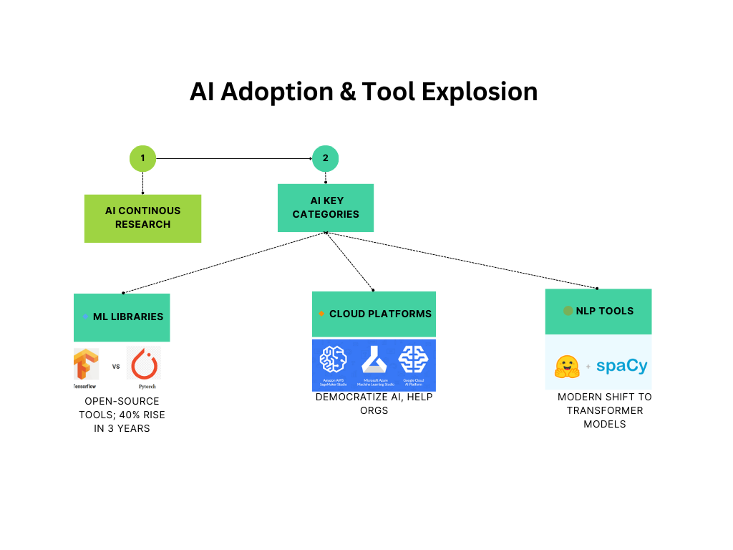

# 3. Categorization of AI Tools

To effectively leverage Artificial Intelligence (AI) in real-world applications, practitioners rely on a suite of specialized tools. These tools fall into various categories based on the AI development lifecycle: data preparation, model development, training, deployment, and monitoring. This section categorizes and evaluates key tools used across these stages.

**3.1 Machine Learning Libraries**

**TensorFlow**

Developed by Google, TensorFlow is a powerful open-source library used for deep learning and machine learning. Its support for scalable production environments and integration with tools like TensorBoard and TFLite make it ideal for both research and enterprise applications.

* Real-world use case: Google Photos uses TensorFlow for image recognition and categorization.
* Strengths: Highly scalable, supports both CPU and GPU computing, large community.

**PyTorch**

Created by Facebook’s AI Research lab, PyTorch is known for its dynamic computation graph and intuitive interface, making it especially suitable for research and rapid prototyping.

* Real-world use case: OpenAI used PyTorch for training early GPT models.
* Strengths: Research-friendly, great debugging, strong community support.

**Scikit-learn**

A user-friendly Python library that supports traditional ML algorithms like regression, classification, and clustering. It’s best suited for small-to-medium datasets.

* Real-world use case: Used in academic ML courses and lightweight applications.
* Strengths: Simplicity, excellent documentation, good for beginners.

**Keras**

Originally a standalone deep learning library, Keras is now tightly integrated with TensorFlow. It provides a simplified API for building neural networks quickly.

**MXNet**

Apache MXNet is designed for speed and scalability, with native support for distributed computing.

**Fast.ai**

Built on top of PyTorch, Fast.ai enables rapid prototyping with minimal code, making deep learning more accessible to beginners.

**H2O.ai**

An open-source AutoML platform that simplifies the process of training and deploying ML models. H2O Driverless AI allows users to build models without writing code.

**3.2 AI Development Platforms**

**Google Cloud AI Platform**

Provides tools for training, evaluating, and deploying models. Includes AutoML and integration with TensorFlow.

* Pricing: Offers a limited free tier (e.g., 10 GB storage, 1 training job/month).
* Notable use: Google's own services leverage this for internal AI operations.

**Microsoft Azure Machine Learning**

A scalable platform with features like drag-and-drop model design, automated ML, and model versioning.

* Pricing: Pay-as-you-go model; limited free services for students and small projects.

**IBM Watson**

Best known for its NLP services, Watson supports model training and deployment for enterprises.

* Use case: Used by The Weather Company and various healthcare platforms for predictive analytics.

**AWS SageMaker**

Amazon’s end-to-end ML service with tools for data labeling, model training, tuning, and hosting.

* Free tier: Offers 250 hours of t2.medium notebook instances for 2 months**.**

**GCP Vertex AI**

An upgrade to AI Platform, Vertex AI integrates Google’s AutoML and custom training services into a single interface.

**3.3 Data Annotation Tools**

**Labelbox**

Cloud-based platform that enables teams to annotate image, video, and text data collaboratively.

* Use case: Used by self-driving car companies for labeling LIDAR and camera data.

**CVAT (Computer Vision Annotation Tool)**

Developed by Intel, CVAT is an open-source annotation tool optimized for computer vision tasks.

* Features: Bounding boxes, segmentation masks, multi-user support.

**3.4 NLP Frameworks**

spaCy

Efficient, industrial-strength NLP library used for tokenization, parsing, and named entity recognition (NER).

**NLTK**

A comprehensive library aimed at research and teaching. Covers basic NLP tasks like stemming and tagging.

**Hugging Face Transformers**

Offers a wide range of pre-trained models (like BERT, GPT, T5) for NLP tasks such as sentiment analysis, translation, and question answering.

* Use case: Used by startups and research labs to fine-tune language models without starting from scratch**.**

# 4. Use Cases

The application of AI tools spans across multiple industries, from healthcare and finance to entertainment and transportation. Each tool serves a distinct purpose, making it vital for practitioners to choose the right combination of tools for their specific tasks. This section highlights some key use cases where AI tools have made significant contributions.

**4.1 Healthcare**

AI tools have made a profound impact on the healthcare industry, improving diagnostic accuracy, patient care, and treatment planning.

* **TensorFlow in Medical Imaging**: TensorFlow has been used to develop deep learning models for detecting diseases from medical images. For instance, Google's AI model, trained on TensorFlow, can detect diabetic retinopathy in eye scans, helping clinicians provide faster diagnoses.
* **PyTorch in Drug Discovery**: PyTorch is used in drug discovery by enabling researchers to predict protein structures, which plays a critical role in finding effective treatments. The ability of PyTorch to dynamically adjust and handle large datasets is an advantage in this complex domain.

**4.2 Finance**

AI tools are increasingly being utilized in the finance industry for tasks such as fraud detection, automated trading, and risk management.

* **Scikit-learn for Credit Scoring**: Scikit-learn’s robust support for traditional machine learning algorithms makes it a popular choice for building credit scoring models. Financial institutions use it to assess loan eligibility, detect fraudulent transactions, and identify high-risk accounts.
* **AWS SageMaker for Algorithmic Trading**: AWS SageMaker provides an end-to-end solution for building, training, and deploying trading algorithms. Hedge funds and investment firms leverage it to create predictive models that execute trades based on market movements.

**4.3 E-commerce and Retail**

The retail sector is increasingly adopting AI tools to enhance customer experience, optimize supply chains, and improve inventory management.

* **PyTorch and TensorFlow for Recommendation Systems**: AI tools like PyTorch and TensorFlow power recommendation engines used by e-commerce platforms such as Amazon. These tools analyze customer behavior, preferences, and previous purchases to recommend products in real-time, boosting sales and customer satisfaction.
* **Keras for Chatbots**: Keras is often used in the development of intelligent customer service chatbots, enabling businesses to automate customer interactions and provide 24/7 support. These chatbots are capable of answering queries, processing orders, and assisting customers on various platforms.

**4.4 Autonomous Vehicles**

The self-driving car industry relies heavily on AI tools to develop safe and efficient autonomous systems.

* **TensorFlow and OpenCV in Self-Driving Cars**: TensorFlow, along with computer vision libraries like OpenCV, is widely used in self-driving car applications to process visual data from cameras and sensors. These tools enable autonomous vehicles to detect obstacles, read traffic signs, and navigate safely.
* **MXNet in Object Detection**: MXNet’s scalability is leveraged in object detection systems, which is a critical aspect of autonomous vehicle safety. It helps in identifying pedestrians, other vehicles, and road conditions in real-time.

**4.5 Natural Language Processing in Customer Support**

NLP tools like spaCy, NLTK, and Hugging Face’s Transformers are revolutionizing how businesses interact with customers, especially in handling large volumes of customer support queries.

* **spaCy for Sentiment Analysis**: Companies use spaCy to perform sentiment analysis on customer reviews and social media posts. This allows them to gauge public opinion and improve products or services accordingly.
* **Hugging Face in Chatbots**: Hugging Face’s pre-trained models, including GPT and BERT, are widely used in developing conversational AI applications, enabling businesses to automate customer service through chatbots with high accuracy.

**4.6 Agriculture**

AI is also transforming agriculture by helping farmers monitor crops, predict yields, and optimize resource usage.

* **Google Cloud AI for Precision Farming**: Google Cloud AI is used in precision farming to analyze satellite imagery and sensor data to monitor crop health, detect pests, and predict yields, allowing farmers to make data-driven decisions that improve productivity and sustainability.
* **TensorFlow in Crop Prediction**: TensorFlow has been applied to crop prediction models, helping farmers understand weather patterns and make informed decisions about planting and harvesting times.

AI tools are empowering industries worldwide to solve complex problems, automate processes, and unlock new capabilities. As the use cases continue to expand across sectors, the tools themselves will evolve, becoming more powerful, efficient, and accessible to a broader range of users.

# 5. Challenges and Limitations

Despite the increasing accessibility and sophistication of AI tools and platforms, several challenges persist that can hinder the successful development and deployment of AI solutions. These limitations arise from technical, operational, and ethical aspects, and they affect users ranging from students and researchers to large organizations.

**5.1 Steep Learning Curve**

Many AI tools—particularly those involving deep learning frameworks like TensorFlow or PyTorch—require a solid foundation in mathematics, statistics, and programming. Beginners may find the setup, model tuning, and debugging processes overwhelming. While some platforms (e.g., Fast.ai, H2O.ai) attempt to reduce this complexity, advanced customization often still requires substantial technical expertise.

**5.2 Integration and Compatibility Issues**

AI development often involves multiple tools for data processing, model training, and deployment. However, these tools are not always compatible or easily integrable. For example, a model trained in PyTorch might require conversion to ONNX for deployment in certain environments. Integrating data labeling tools (e.g., CVAT) with model training workflows can also involve manual steps and scripting.

**5.3 Cost and Resource Constraints**

Although open-source tools are freely available, effective AI development often requires high-performance computing resources (GPUs/TPUs), which can be expensive. Cloud platforms like AWS SageMaker and GCP Vertex AI offer powerful services, but their pricing can be prohibitive for startups, students, or researchers in underfunded institutions—especially when projects scale.

**5.4 Data Quality and Labeling Bottlenecks**

The performance of machine learning models heavily depends on the quality and quantity of training data. Manual data labeling is time-consuming and prone to human error. Even with advanced annotation platforms like Labelbox, maintaining consistency and managing large datasets remains a major challenge.

**5.5 Model Interpretability and Explainability**

Many modern AI models, particularly those using deep learning, operate as "black boxes," making it difficult to understand how they arrive at specific outputs. This lack of transparency can be problematic in sensitive applications such as healthcare, finance, and law, where explainability is essential.

**5.6 Ethical and Privacy Concerns**

The use of AI tools for handling personal data raises ethical issues related to bias, fairness, and privacy. For instance, facial recognition models trained on non-diverse datasets may produce biased results. Tools must comply with regulations like GDPR, and developers need to ensure ethical data collection and model auditing practices.

**5.7 Rapid Evolution and Tool Obsolescence**

The AI ecosystem evolves rapidly, with frequent updates, deprecations, and the emergence of new tools. Developers must constantly adapt to changing APIs, best practices, and community standards. This volatility can lead to codebase instability and increased maintenance efforts.

By acknowledging these challenges, researchers and developers can make informed decisions when selecting AI tools and designing workflows. Addressing these limitations also opens avenues for future research and innovation, such as developing more intuitive interfaces, improving interoperability, and enhancing transparency in AI systems.

# 6. Future Outlook

As the field of Artificial Intelligence continues to evolve, so too will the tools and platforms that support its development. Future trends suggest a move toward greater accessibility, automation, and ethical responsibility, enabling broader adoption across industries and user types.

**6.1 Rise of Low-Code/No-Code Platforms**

One of the most significant trends in AI tool development is the emergence of low-code and no-code platforms. These platforms allow users with little or no programming experience to build, train, and deploy AI models through drag-and-drop interfaces or automated workflows. Tools like Google AutoML, Microsoft Azure ML Studio, and H2O Driverless AI are already pioneering this space. As they mature, these platforms will enable subject-matter experts to contribute to AI innovation without needing deep technical knowledge.

**6.2 Greater Automation and AutoML**

Automated Machine Learning (AutoML) is poised to revolutionize how AI models are developed. AutoML tools automate key tasks such as feature selection, model selection, hyperparameter tuning, and even deployment. In the future, these tools will become more accurate and efficient, minimizing human intervention and reducing time-to-market for AI solutions.

**6.3 Integration of Explainable AI (XAI)**

Transparency and trust are critical for the widespread adoption of AI, especially in sensitive domains like healthcare, finance, and law. Explainable AI (XAI) seeks to make AI decisions understandable to humans. Frameworks such as LIME, SHAP, and IBM AI Explainability 360 are already addressing this issue, and future tools will likely incorporate XAI by default to ensure regulatory compliance and foster user trust.

**6.4 Edge AI and Federated Learning**

As IoT devices become more prevalent, there is a growing need to process data closer to its source—at the edge. Edge AI allows models to run on devices such as smartphones, cameras, and microcontrollers, reducing latency and enhancing privacy. Tools like TensorFlow Lite and OpenVINO are leading this transformation. Meanwhile, federated learning enables decentralized model training on local data, which is crucial for privacy-sensitive applications.

**6.5 Interoperability and Ecosystem Integration**

The future will also demand better interoperability between tools. Open standards and shared model formats like ONNX (Open Neural Network Exchange) are steps in this direction. Seamless integration between data labeling, model training, deployment, and monitoring tools will become essential, leading to the rise of unified AI development ecosystems.

**6.6 Ethical AI by Design**

Ethical considerations will play an increasingly central role in AI development. Future platforms will include built-in tools for bias detection, fairness audits, and compliance checks. As public awareness and regulations grow, ethical AI will move from being an option to a requirement.

The future of AI development tools is not just about increasing computational power or algorithmic performance. It is about democratizing AI, making it trustworthy, and embedding it responsibly into everyday life. As these tools evolve, they will not only shape the next generation of AI applications but also the way society interacts with intelligent systems.

# 7. Conclusion

Artificial Intelligence is revolutionizing the way industries operate, innovate, and make decisions. The development and success of AI systems heavily depend on the use of appropriate tools and platforms that support the entire AI lifecycle—from data collection and labeling to model training, deployment, and monitoring. This paper has provided a comprehensive overview of key AI tools, categorized into machine learning libraries, development platforms, annotation tools, and NLP frameworks.

By analyzing tools like TensorFlow, PyTorch, Scikit-learn, and platforms such as AWS SageMaker, GCP Vertex AI, and IBM Watson, the paper highlights their strengths, use cases, and practical applications. It also addresses the challenges users face, such as steep learning curves, integration issues, and ethical concerns. Additionally, the paper outlines future trends, including the rise of no-code solutions, explainable AI, and federated learning, which promise to make AI more accessible, interpretable, and responsible.

As the AI ecosystem continues to evolve, selecting the right tools and understanding their capabilities will remain a critical factor in the success of AI initiatives. Future research should focus on benchmarking tools, improving interoperability, and exploring the ethical dimensions of AI systems to ensure their safe and equitable deployment.

**References**

1. Gartner. (2023). AI Tool Trends and Market Share.
2. Nguyen, K. T., & Nguyen, H. D. (2022). Designing AI for Development. IEEE.
3. Hugging Face Documentation. [https://huggingface.co](https://huggingface.co/)
4. TensorFlow Guide. [https://www.tensorflow.org](https://www.tensorflow.org/)
5. Microsoft Azure ML Docs. <https://learn.microsoft.com/en-us/azure/machine-learning/>
6. Scikit-learn Documentation. [https://scikit-learn.org](https://scikit-learn.org/)
7. IBM Watson Overview. <https://www.ibm.com/watson>
8. CVAT GitHub Repo. <https://github.com/openvinotoolkit/cvat>